Psychology Research Methods Introductory (HPS201/HPS771)
Assignment

Task 6: ANOVA and Post-Hoc Tests
______________________________________________________________

Experiment 1

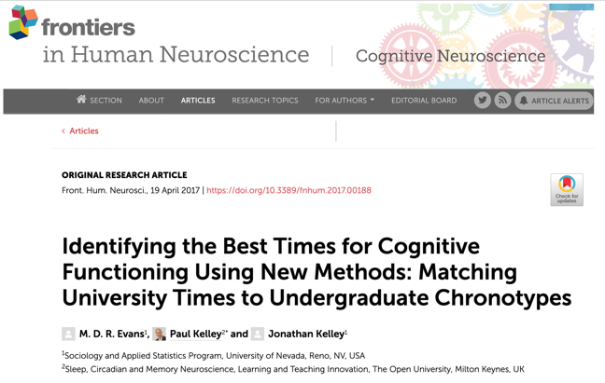
Cognitive theory suggests that college students learn best if they study later in the day (Evans et al., 2017). Your task as a researcher is to test this idea.

To this end, you recruit 63 undergraduate students of similar cognitive and academic ability. You then randomly allocate each student to one of three groups (Group A, Group B or Group C). All students study for the same exam over a two-week period (all students study for the same number of hours). Students in Group A study in the morning. Students in Group B study in the afternoon. Students in Group C study in the evening.

At the end of the two-week period, all students sit the same exam (scores on the exam range from 0 to 40 with higher scores indicating better exam performance). Finally, you conduct a One-way Anova to test if the three groups differ in their mean exam scores. You obtain the following output from the analysis:

Statistical Output

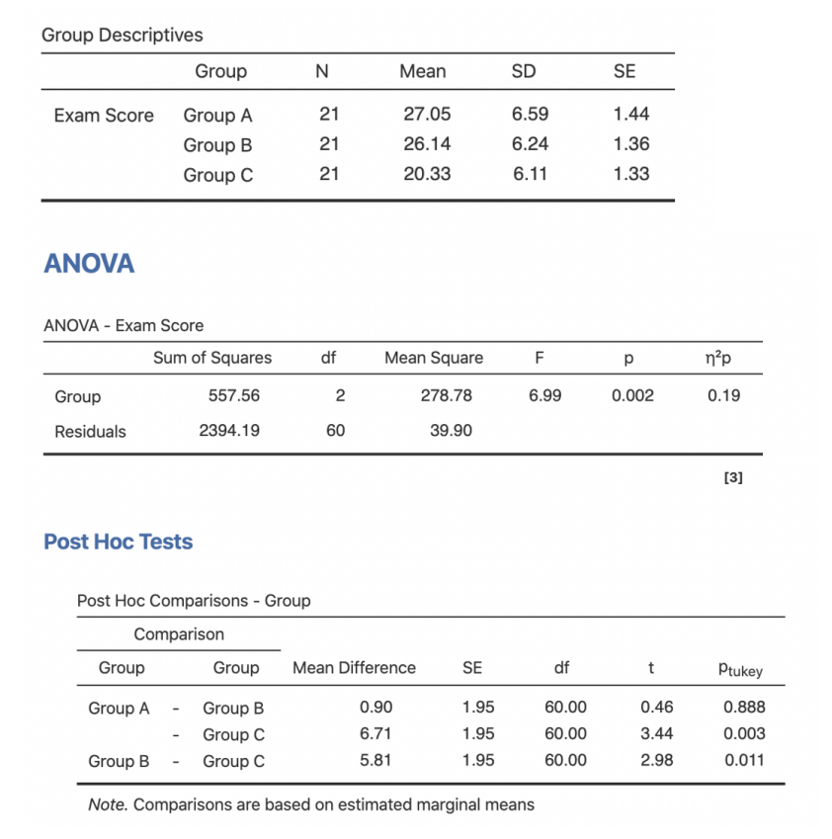
Experiment 1 - Questions

- With help from the unit materials, report the results of the analysis (including relevant post-hoc analyses if applicable) in APA format including all relevant information. (4 Marks)
There was statistically significant difference in the mean exam scores for the three groups as determined by One-way ANOVA (F(2,60)=6.99,P=0.002).
Post hoc comparisons using the Tukey HSD test indicated that the mean exam score for Group A (M=27.05, SD=6.59) was not significantly different than Group B (M=26.14, SD=6.24). However, the mean exam score for Group C (M=20.33, SD=6.11) was significantly different from Group A and Group B

- Assume you are a Cognitive Psychologist. Based on the results of this study, what would be your recommendation to students studying for an exam? Justify your response. (1 Mark)
Based on the results above, I would recommend students to study in the morning and in the evening for best exam scores.

- When comparing the largest to the smallest mean in Experiment 1 using post-hoc analysis, the critical value for the Studentized Range Statistic (q) is 3.40. Assume that the observed difference in the average exam score between Group A and Group C is 4.20. Is this difference statistically significant? Justify your response. (3 Marks)
Since the observed difference in the average exam score between Group A and Group C is 4.2 and 4.2 is greater than 3.4, we can conclude that the difference is statistically significant.

Experiment 2

Dr Acai wants to investigate if excessive screen time may be linked to reduced creativity in childhood. To investigate this question, she measures creativity in a group of primary school aged children using the Test of Creativity (ToC). Scores on the ToC are normally distributed (M = 100, SD = 15) with higher scores indicating higher levels of creativity. She also records the average daily screen time (in minutes) for each child (assessed using parent report).

Based on World Health Organisation recommendations that children should not engage in more than 120 minutes of screen time per day, Dr Acai allocates each child into one of three groups based on their daily screen time. Children in Group A report less than 120 minutes of screen time per day. Children in Group B report 120-180 minutes of screen time per day. Children in Group C report more than 180 minutes of screen time per day.

Dr Acai then runs a One-way ANOVA to test if the three groups differ in their mean creativity. She obtains the following output form the analysis:

Statistical Output

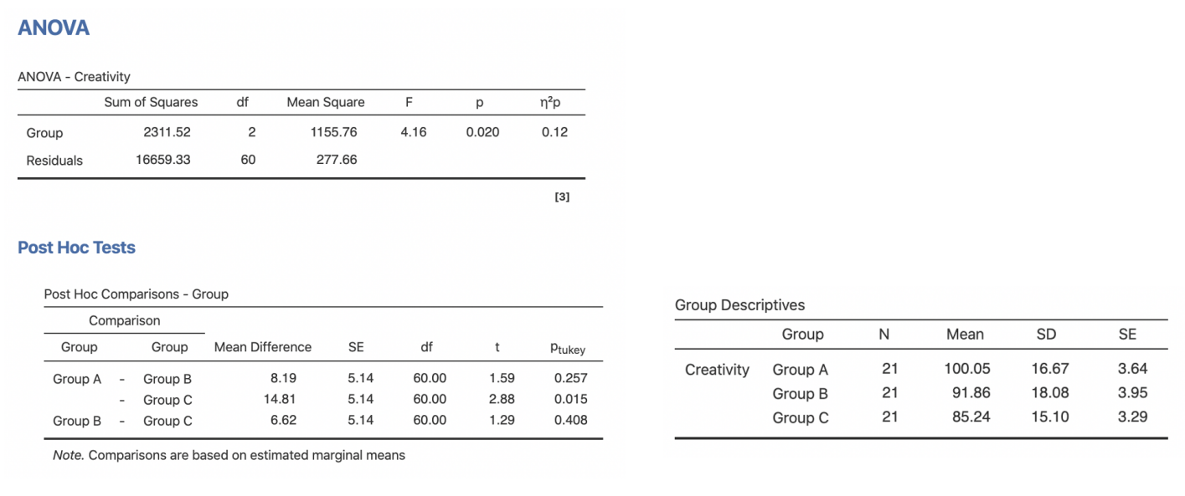

Experiment 2 – Questions

- Dr Acai concludes that children who report 120 minutes or more of screen time per day are at risk of presenting with low creativity. Is this conclusion valid based on the data? Justify your response. (2 marks)
No. Because, from the Post hoc comparisons, it is evident that there is no statistically significant difference in the mean creativity between Group A and B.

